
Welcome to Women’s Healthcare Group of Illinois (WHCG). We want to thank you for choosing WHCG for your healthcare needs. We ask that all registration paperwork be completed in its entirety before your visit. We also require that you bring your insurance card, a valid form of photo ID and your co-pay (if required). Should you have any questions or if you need additional information, please do not hesitate to contact our office.
Appointment Policy Agreement
Due to the high demand for appointments at WHCG, we have created a “no show” or same day cancellation policy. Included in this policy is the requirement that ALL cancellations must be made at least 24 hours in advance of a schedule appointment. Any cancellation made less than 24 hours prior to an appointment will be considered a “no-show”. If you have three or more “no show” appointments with in a 24-month period, we reserve the right to refuse you future appointments. For every “no show”, there is also a $25 no show fee that you will be billed.
We ask that all patients arrive for their appointments at least 10 minutes before their appointment time. This allows enough time for patients to be checked in, to complete any needed paperwork and for them to complete their in-take with the nurse before their scheduled appointment time arrives. It is our goal to accommodate as many patients as we can while ensuring that we see them in a timely and efficient manner. Anyone who is more than 10 late for their appointment may be required to reschedule their appointment for a later time and/or date. I you have any questions or concerns, please contact our office.
Patient Notification Preference
If for any reason, including test to share test results (both normal and abnormal), our office needs to contact you, how would you prefer to be contact?
⃝ Home Phone Home Number __________________________________________
⃝ Leave Message with details (no test results are left on voice mail)
⃝ Leave brief message to call office back.
⃝ Do not leave a message.

⃝ Cell Phone Cell Number ___________________________________________
⃝ Leave Message with details (no test results are left on voice mail)
⃝ Leave brief message to call office back.
⃝ Do not leave a message.

⃝ Mail Notification Mailing Address ______________________________________________
I hereby acknowledge that, as a patient of Women’s Healthcare Group of Illinois, I have read and agree to the above.
_________________________________________ ________________________________________
Patient Name Patient and/or Guardian Signature

__________________________ ________________________________________
Patient Date of Birth Relationship to Patient

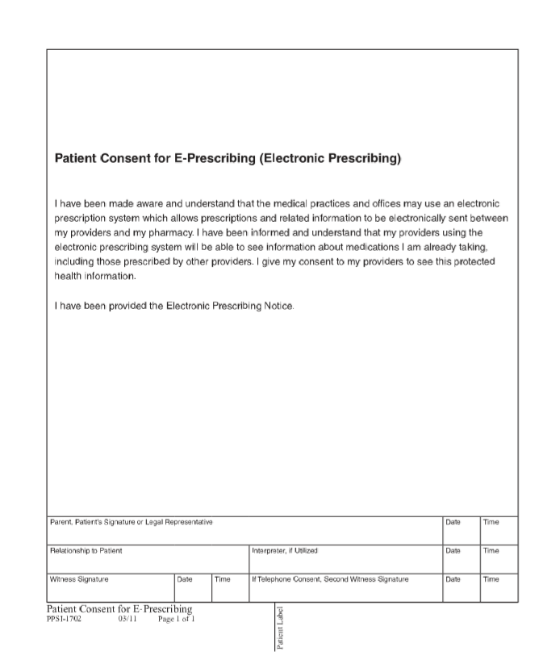

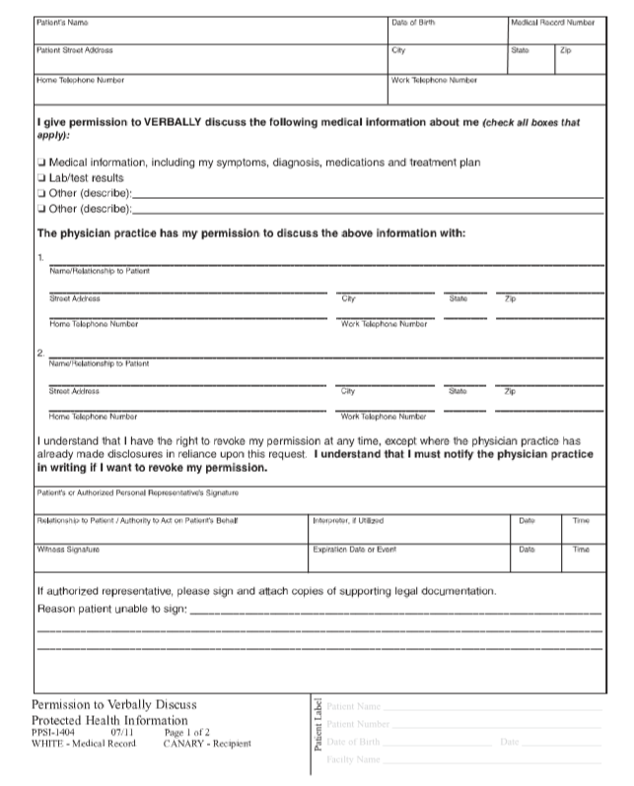

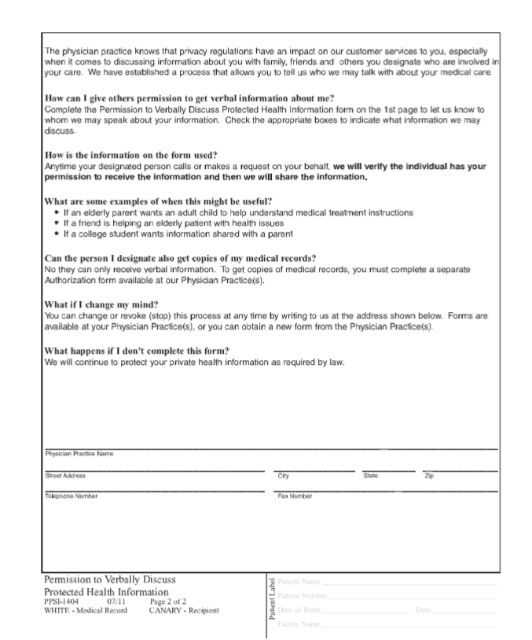

Women’s Healthcare Group of Illinois Patient Registration

About the Patient:

Patient Last Name Patient First Name Gender □M □F

Date of Birth Social Security Number Occupation

Address City State Zip

Home Phone Number Cell Work

Marital Status: □Single □Married □Domestic Partnership □Divorced □Separated □Widowed Employer Employer Address
About the Patient’s Guardian and/or Spouse:

Guardian/Spouse Last Name Guardian/Spouse First Name

Date of Birth Social Security Number Occupation

Address City State Zip

Home Phone Number Cell Relationship to Patient

Marital Status: □Single □Married □Domestic Partnership □Divorced □Separated □Widowed Employer Work Phone Employer Address
Billing Information:

Bills should be sent to: □Patient □Spouse □Guardian

Mailing Address for Bill is: □Same as above □Other

Emergency Contacts:

Name Phone Relationship to Patient

Name Phone Relationship to Patient

Insurance Information:

Primary Insurance Policy ID Number

Policy Holder’s Name Group Number Policy Holder SSN

Employer (that Insurance is through) Effective Date

Claims Address Insurance Phone Number

Policy Holder’s Date of Birth Policy Holder’s Relationship to Patient

Secondary Insurance Policy ID Number

Policy Holder’s Name Group Number Policy Holder SSN

Employer (that Insurance is through) Effective Date

Claims Address Insurance Phone Number

Policy Holder’s Date of Birth Policy Holder’s Relationship to Patient_

I authorize the release of any medical information necessary to coordinate care with other physicians and to process insurance claims. I understand that I am financially responsible for all charges whether or not paid by my insurance company and authorize my insurance company to pay directly to Women’s Healthcare Group of Illinois.

Patient/Guardian Signature _____________________________________________________________ Date________________________________________________

Patient Self History (Please complete BOTH pages completely)

Date: Patient Name:
Address: Birth Date:
Have you ever been in the hospital or had surgery? If yes, for what and when?

Pregnancies: Number
Living Children
Miscarriages
Abortions

Medical History: Please circle all past or present medical problems and/or symptoms.

Anemia | Heart Disease | Any Other Bleeding
Arthritis | Chest Pain | Easy Bruising
Asthma | High Blood Pressure | Abnormal Vaginal Discharge
Cancer | Kidney Disease | Abnormal Penile Discharge
Diabetes | Prostate Disease | Psychiatric Problems
Fibroids | Urinary Incontinence | Seizures
Gout | Difficulty Urinating | Stroke
Alcoholism | Liver Disease | Thyroid Disease
Glaucoma | Lung Disease | Tuberculosis
Hearing Loss | Shortness of Breath | HIV
Visual Loss | Ulcers | Sexually Transmitted Disease
Heart Attack | Gastrointestinal Bleeding | Drug/Substance Abuse

Medication History: Please list medications you are currently taking:
Medication How Often? For What Problem?

Allergies: List any medications or other substances that you are Allergic to:

Social History: Do you smoke? If yes, how much and how often?

Do you drink alcohol? If yes, how much and how often?

Do you use illicit drugs? If yes, what kind and how often?

What is your occupation?

Is there any exposure to dust, fumes, smoke or noise?

Are you watching your diet or following any strict dietary guidelines?

Do you exercise regularly?

Do you take any non-prescription medications, health foods or vitamins?

Advance Directives: Do you have someone named as Power of Attorney for Healthcare?

If yes, whom? Do you have a Living Will Declaration? (If you would like information regarding these Advance Directives, ask front desk for information)

Family History: (Immediate only: father, mother, brothers, sisters and grandparents)
Alive? Age Medical Problems or Cause of Death

Father Mother Siblings Grandparents Other

Health Screenings/Immunizations: Please specify if you had any of the following.
Date & Results:
Pap Smear
Mammogram
Chest x-ray
Physical Exam
Digital Rectal Exam
Prostate Exam/PSA
Stool Hemoccult
Flexible Sigmoidoscopy
Colonoscopy
Cholesterol
Blood Sugar
B.M.I.
PPD
Influenza Vaccine
Tetanus/TD
Hepatitis B Vaccine

Chicken Pox or Vaccine

***This has been reviewed by Doctor (Drs Initials) Updated (yearly)

